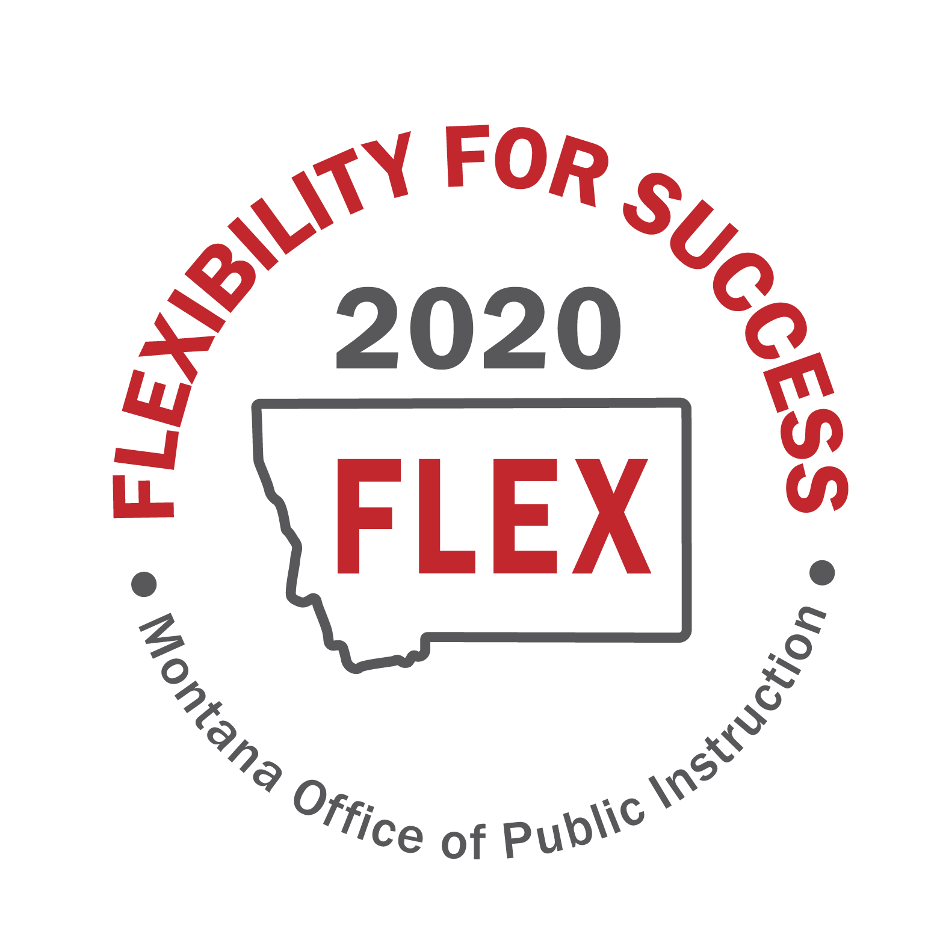

“MT FLEX2020” Task Force
Session 2
June 3rd, 2020
Focus Group Note Catcher

Focus Group: D-Fostering and supporting local innovation
Note Taker: Lona Running-Wolf
Group Members: Dinny Bennett, Forsyth Public Schools Superintendent
Michelle Halberg, Special Education Director, Gallatin-Madison Special Education Cooperative
Gregory Dern, Roy Public Schools Superintendent
Wade Sundby, Glasgow Public Schools Superintendent
Pad McCracken, Lead Staff, Education Interim Committee Montana Legislative Services
Jon Konen, Great Falls Public Schools Principal

Questions | Time Allotment | Notes
- After pondering the Essential Questions, what key ideas come to mind?  - Write key ideas that come to mind  - Do not judge or discuss the ideas  - Come up with as many ideas as possible |  | Collaboration-  Having the ability to collaborate with each other on what is going on out there in remote learning, good things are happening, and we need to be sharing these innovations. Having a conference or sessions that allow districts to come together to learn from each other. OPI can help by facilitating educator support links or regional support teams from districts with the same demographics to be able to learn from each other. Also, provide training for leadership.  New Educational Paradigms-  Reinventing public education has good outline on how to redesign policies. We are all custom to a tailored system of learning, schedules and accreditation prescribe how these systems work and we are looking to break out of the mold. Districts can be empowered to design their own paradigm/model that works best for them but they need the many flexibilities to be in place through local, state, and federal requirements in order to do this. Most of all we need time. This is going to be a big changes and require a lot of time and energy and we can’t try to fix it fast, it is going to be a learning process for all districts, all agencies will have to be flexible with districts so that this new norm can be developed, trial and error, and designed. OPI can help through guidance but it has to be the districts that are defining the new paradigm shift.  To be innovative in education it will require:  1.Student Flexibilities-Some students were more successful in remote learning rather than in classroom. This blended learning model will get all students involved.  -Transformational learning bill – was an effort to support and foster innovation. Anything that is under the umbrella of student-centered and learner centered is the direction we need to go. It takes time and effort to learn how to be transformational.  2. Teacher Flexibility- Training is going to be important. Teachers must be able to be creative and innovative and that will require time to train them. During COVID, teachers that had more success were the teachers that were able to think outside the box, develop relationships. These teachers were going into homes to connect with their students (social distancing), these teachers did things that were connecting to them socially and emotionally, teaching was innovative and not always the same. Teachers have to have the flexibility to design learning that is student centered.  3. Union flexibility- Union issues will arise due to change of working conditions, we will have to be flexible in working together to make sure learning is working for students and staff as well as the community. Collective bargaining may have to change to what supports students as well as teachers so that teacher burn out is not happening.  4. Parent/Community flexibility- parents and community will have to be active participants in this new model, what considerations will have to be put into place for them? Some parents are going to want students to be in school rather than remote. How do we work with parents and their schedules or how do we support students that do not have the support at home? Flexibility in seat time and aggregate hours will have to be considered to meet the needs of community and parents. Extra-Curricular- Another factor that helps with student engagement and retention (MHSA rules?) but what will that look like in this new model?  5. Schedules/Time Flexibility- We can’t rely on a one-size fits all, giving ourselves time to develop models. The start of flexibility means we have to be okay with everything not being perfect, finding what fits each demographic. Collaboration is key. We still want local control, but we need to be able to work together with other districts. Pre-Coved schedules were always set, now things will be different because we have to work with the schedules of homes and parents. Time may have to be flexible.
Whole Group Share-Out | 10 minutes | Share out group responses for # 1 and #2
3) Evaluate the Ideas  - What flexibilities are needed to address the key ideas and opportunities?  - Evaluate the flexibilities based on the following criteria: Specific; Balanced; Realistic; Lasting; Fair | 15 minutes | New Paradigm- All flexibilities need to give time to develop their own methodology to design and assess learning programs.  Administrator training- regional conferences to help develop evaluation models (backwards design) for state guidance.  Guidance from state regarding Funding.  Teacher training to help support the new paradigm.  Time- When will planning happen? Do we need extra PIR days?  Seat Time needs to be flexible.  Transformational Learning- this would be beneficial to a remote and blended learning-the grant process needs to be funded in a way to have more applicants. Self-directed philosophy is needed.

